**Apple Watch**

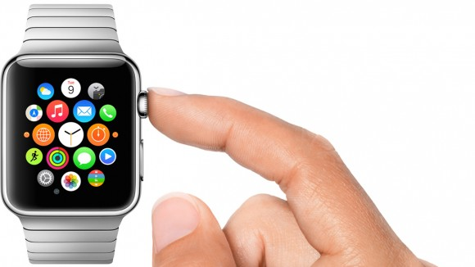

Pressing the crown wheel

To be released in early 2015 is the Apple Watch, not called as you might expect the iwatch, will probably see many people stop using their smart phone as much, but soon start using a smart watch.

There will be three different styles of Apple Watch to choose from in two sizes each.

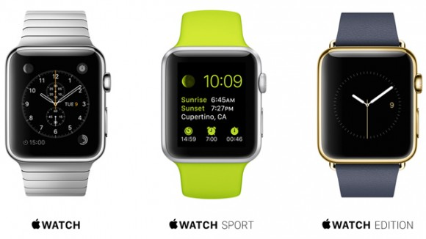

Which style do you prefer?

The crown wheel on the watch is a circular button on the side which is pressed and turned to use the watch, and under that is another button that you press to talk to people, called the talk button.

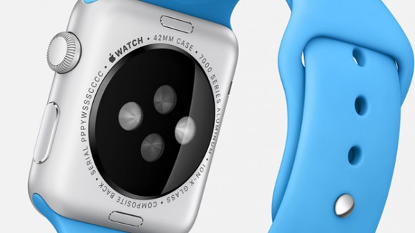

Crown wheel and talk button on the side

When you have a message or social media updates the strap will vibrate in different ways. The watch on the back has some sensors and knows how much exercise you are doing, your heart rate and how many calories you have burned, the idea is to help people live a healthier lifestyle.

The watch is said to be very accurate as it checks the time against global time and always changes the time wherever you are by using GPS. The battery life is said to probably be about a day, so it will need to be charged every night.

As well as this you can of course make phone calls on the watch, send texts, emails, and you can use it to buy things, with a built-in payment system connected to your credit card. It also works to control the music on your iphone or see what your iphone camera sees.

The retail price is expected to be about $349 US dollars.

**True, False or Not Given?**

1. The talk button is on the side of the watch.

2. You will have to set the time yourself.

3. The watch has a camera.

4. The watch knows how much exercise you are doing.

5. The watch will be released in March 2015.

6. The watch isn’t very accurate.

7. You can buy things with the watch.

8. The watch will cost 500 dollars.

**Discussion**

* Would you like to own an Apple Watch?
* What style of Apple watch would you buy?
* Do you think that your parents would like one?
* Do you think it’s too expensive?
* Would you use it for sport?
* Do you think many people will have one or will they be unpopular?
* Do you think more people will buy them in the USA, or more people will buy them in your country?

1. True

2. False

3. Not given

4. True

5. Not Given

6. False

7. True.

8. False